Settlement Network
# Source: AI Source: Provided by: [Data Path: Persons Table -> ID Column: 1, Name_En Column: Motasem Essam] -> From: [ChatGPT] on [1/21/2026]
A Settlement Network is the part of a payment system responsible for the final transfer of money between financial institutions — typically from the payer’s bank to the payee’s bank. It ensures that approved transactions are completed and that actual funds are moved behind the scenes.

🧠 Simple Definition
# Source: AI Source: Provided by: [Data Path: Persons Table -> ID Column: 1, Name_En Column: Motasem Essam] -> From: [ChatGPT] on [1/21/2026]
A Settlement Network moves the money after a payment is approved. It's where the “real” financial exchange happens between banks or payment providers.

🔄 Where It Fits in the Payment Flow
# Source: AI Source: Provided by: [Data Path: Persons Table -> ID Column: 1, Name_En Column: Motasem Essam] -> From: [ChatGPT] on [1/21/2026]
- A transaction is authorized (approved by card issuer or bank).
- But no money has moved yet — only a promise to pay.
- The Settlement Network moves the actual funds between accounts.
- The merchant receives the money into their bank account.

🏛️ Types of Settlement Networks
# Source: AI Source: Provided by: [Data Path: Persons Table -> ID Column: 1, Name_En Column: Motasem Essam] -> From: [ChatGPT] on [1/21/2026]
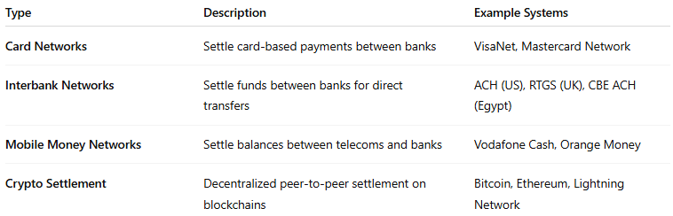

Type | Description | Example Systems
Card Networks | Settle card-based payments between banks | VisaNet, Mastercard Network
Interbank Networks | Settle funds between banks for direct transfers | ACH (US), RTGS (UK), CBE ACH (Egypt)
Mobile Money Networks | Settle balances between telecoms and banks | Vodafone Cash, Orange Money
Crypto Settlement | Decentralized peer-to-peer settlement on blockchains | Bitcoin, Ethereum, Lightning Network

📦 Key Responsibilities
# Source: AI Source: Provided by: [Data Path: Persons Table -> ID Column: 1, Name_En Column: Motasem Essam] -> From: [ChatGPT] on [1/21/2026]
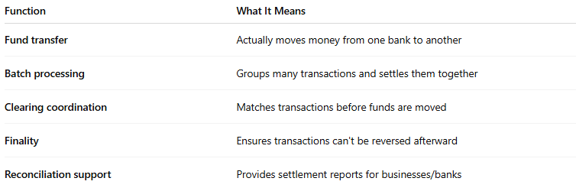

Function | What It Means
Fund transfer | Actually moves money from one bank to another
Batch processing | Groups many transactions and settles them together
Clearing coordination | Matches transactions before funds are moved
Finality | Ensures transactions can't be reversed afterward
Reconciliation support | Provides settlement reports for businesses/banks

💡 Real-World Example
# Source: AI Source: Provided by: [Data Path: Persons Table -> ID Column: 1, Name_En Column: Motasem Essam] -> From: [ChatGPT] on [1/21/2026]
A customer buys from your online store using a Visa card:
✅ Card network (Visa) approves the transaction.
🕓 1–2 days later, Visa’s settlement system transfers money from the issuing bank to your acquiring bank, who then deposits it to your merchant account.

🔐 Why Settlement Networks Are Critical
# Source: AI Source: Provided by: [Data Path: Persons Table -> ID Column: 1, Name_En Column: Motasem Essam] -> From: [ChatGPT] on [1/21/2026]
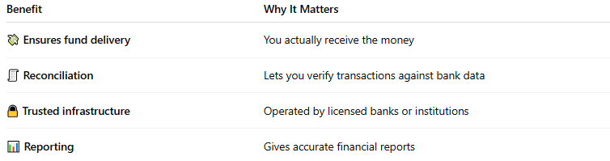

Benefit | Why It Matters
💸 Ensures fund delivery | You actually receive the money
🧾 Reconciliation | Lets you verify transactions against bank data
🔒 Trusted infrastructure | Operated by licensed banks or institutions
📊 Reporting | Gives accurate financial reports

🧠 Summary
# Source: AI Source: Provided by: [Data Path: Persons Table -> ID Column: 1, Name_En Column: Motasem Essam] -> From: [ChatGPT] on [1/21/2026]


Aspect | Settlement Network
What it does | Moves actual funds between payer’s and payee’s banks
When it happens | After transaction is approved (in hours or days)
Who runs it | Card networks, central banks, financial systems
Why it matters | Ensures merchants get paid and records are accurate

